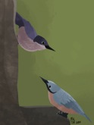

The CHATTER May 2023

Birders’ Night
Birders’ Night, May 18, 7 PM: Of Ravens Wolves and People: With his extraordinary research on the intelligence and startling abilities of corvids - crows, ravens, and jays, scientist Dr. John Marzluff tells amazing stories of these brilliant birds and offers us an in-depth look at these complex creatures and our shared behaviors. Dr. John Marzluff is a Professor of Wildlife Science at the University of Washington School of Environmental and Forest Studies. Crows are mischievous, playful, social, passionate, and eloquent, with brains huge for their body size. They mate for life and associate with relatives and neighbors for years. And they know us. They live in our gardens, parks, and cities, they recognize our peculiarities, they avoid those who scold or threaten, they approach those who care for and feed them. They give us gifts. Humans and corvids have culturally co-evolved and we share the seven traits of language, delinquency, frolic, passion, wrath, risk-taking, and awareness.
John will present remotely via Zoom. You have the option of meeting in person at the Environmental Center (16 NW Kansas Ave.) or via Zoom => BN May18.
If you have missed Birders' Night, you can view past talks on the ECAS YouTube channel here: Past BNs.
June, July, August: Nothing scheduled, Go birding.
September 21: A History of Oregon Ornithology: From Territorial Days to the Rise of Birding by Alan L. Contreras.

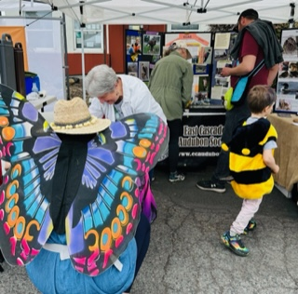
ECAS and Earth Day
After an absence of three years due to the Covid restrictions, Earth Day was back in fine form and ECAS was a part of it. On April 22 volunteers Wendy Andrick, Elise Wolf, Jan Clark, and Mardi Jensen helped out at the booth by the Environmental Center. Duke Tufty later joined them for another presence at Worthy Brewing. They reported many folks stopped by to ask questions about wild birds including the bumblebee and butterfly in the photo taken by Wendy Andrick.

Dean Hale Woodpecker Festival 2023 Update
Registration is open until May 31 for several field trips and the Social and Keynote featuring Dr. Matt Orr and Dr. Kurt Trzcinski of OSU,with Steve Shunk speaking about East Cascades Woodpeckers as Keystone Nesters. This promises to be a fun and informative evening at the Five Pines facility in Sisters with door prizes, a local author, charming Board Members and more!
Field trip slots are still available for Native Plants at Crooked River Ranch, Shevlin Park and Bluebird and Kestrel Banding.
Find these events at ecaudubon.org: go to Events, choose Dean Hale Woodpecker Festival, then follow the prompts to Get Tickets.

Spring Into Nature Fest in Madras
The Children’s Forest of Central Oregon is sponsoring a “Spring into Nature Festival” in Madras on May 6 from 11am – 2pm. The event will provide something for everyone, including nature arts and crafts, STEM activities, outdoor recreation, music, food, and more. Family friendly, the event is made possible by 15 community partners including ECAS. If you would like to volunteer to part of this fun event, contact Wendy Andrick at wandrick@yahoo.com

Summer Lake Wildlife Area Breeding Shorebird Survey
The fourteenth Annual Summer Lake Survey will be held Saturday and Sunday, June 3 and 4, 2023. If you would like to help with this ECAS sponsored effort, contact Martin St. Louis at stlouismartin541@gmail.com.

Birding Basics: Field Experiences
Attention Novice Birders and Birders New to Central Oregon! A series of free field experiences is being offered by ECAS, especially for new birders, birders who are new to Central Oregon, and those who want a refresher course. For six months, January - June, ECAS is sponsoring two- hour opportunities to learn about a variety of Central Oregon birding locations, topics, skills, and resources. Sign-ups via Member Planet will be available at the beginning of each month for the first 20 people who sign up. Please cancel your reservation if you find you are unable to (Note: For May only, the limit is 14 participants due to the “birding by ear" topic.) Please cancel your reservation if you find you are unable to attend.
Details for the May 21st Birding Basics: Field Experience:
Topic: Identifying songbirds and waterfowl by sight and sound
Location: Sawyer Park, Bend
Meeting spot: 62999 O.B. Riley Road, Bend (meet at picnic tables by parking lot)
Group Leader: Aaron Jenkins
Date/Time: May 21 (Sunday). Meet at 7:45 a.m., ready to begin at 8:00 a.m. Session lasts till around 10:00 a.m.
Focus: Songbird identification. With ample riparian habitat along the Deschutes River, Sawyer Park is popular among resident and migrant songbird species (and water birds, too). We may encounter various warblers, sparrows, black-headed grosbeaks, warbling vireos, western tanagers, ruby-crowned kinglets, among others.
Skill emphasis: Birding by ear (identifying bird species by their vocalizations)
What to expect: We will be walking 1-2 miles on level ground, which might be muddy and is often windy.
Bring: Binoculars (we will have some loaner binoculars), clean ears, and warm and wind-resistant layers. You might also wish to bring a camera, water, and paper/pen for notes.
Who should sign up? All ages are welcome. There is a limit of 14 participants. ECAS members and non-members are welcome. Please leave your dog at home. Sign up here starting May 1, which will take you to Member Planet. This will get you registered and provide the link to sign the waiver.

www.memberplanet.com/events/eastcascadesaudubonsociety/birdingbasicsfieldexperiencessawyerpark_1

If you have questions, e-mail Gordon Wetzel gordonwetzel@gmail.com or Lynda Paznokas Lpaz@bendnet.com. Please cancel your reservation if you are unable to attend.

ECAS Volunteer Opportunities
ECAS Board President Mary Shivell would like to see some able bodies step forward for two important position openings. Volunteers are what make ECAS such a vibrant organization! They are Board Member and Birder's Night Coordinator. If you are interested in helping out with any of these, contact ECAS at ecaudubon@gmail.com. If you are interested but need to know more about the tasks and time involved for these positions, email Mary at mvshivell@gmail.com.

Opportunities for volunteers in Harney County
In the coming months there will be several bird-counting events that may interest you. Sign-ups for these "Community Science Trips" are available at: https://audubonportland.org/get-involved/community-science/
Camping provided/group-based:
May 25-28: Marshbird Madness (Marshbird bioblitz)
June 21-24: Interior Snowy Plover Survey
August 16-19: Fall Shorebird Survey
August 30-September 3: Blitzen River Mussel Survey

Camping provided/individual-based:
July 15-September 15 (weekly): Greater Sandhill Crane Recruitment (volunteers can stay for 1-week or more, depending on their availability)

On-your-own project:
March-August: Project IBiS

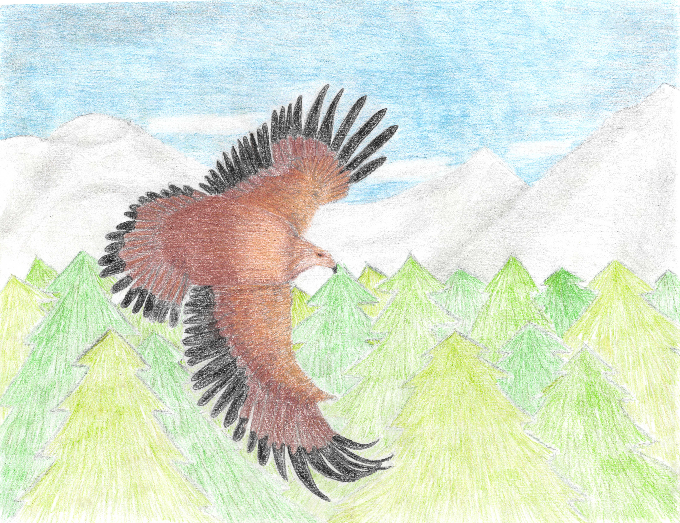
Golden Eagle by Amanda
GOOD BIRDING!

